Community Update

**March 2023**

Church Street Stormwater Drain Rehabilitation

Works are now well underway to rehabilitate the Church Street Stormwater drain between Church Street and College Street, Hawthorn to ensure it continues to operate safely.

## Update on works

The following works are now complete:

* Upgrade to the existing Melbourne Water stormwater maintenance hole near Church Street
* Creation of a new Melbourne Water stormwater maintenance hole near College Street

In the coming weeks we will start:

* Cleaning, inspecting and re-lining the section of drain under Smart Street Reserve between Church Street and College Street, Hawthorn
* Patching sections of the drain along Church Street from Smart Street Reserve to Barkers Road, Hawthorn
* Patching sections of the drain between College Street and Connell Street, Hawthorn

## What to expect

We will re-line the drain from maintenance holes within Smart Street Reserve.

Melbourne Water will make every effort to minimise impacts to community, however during works you may notice:

* Noise from the re-lining process
* Some dust
* Increased vehicle movements in and out of Smart Street Reserve from Smart and College Street
* Temporary closure of Smart Street Reserve during term 1 school holidays
* Pathway diversions within Smart Street Reserve, signage will be in place to safely guide you through the area

***Please note that we will provide advanced notice through signage regarding playground closures.***

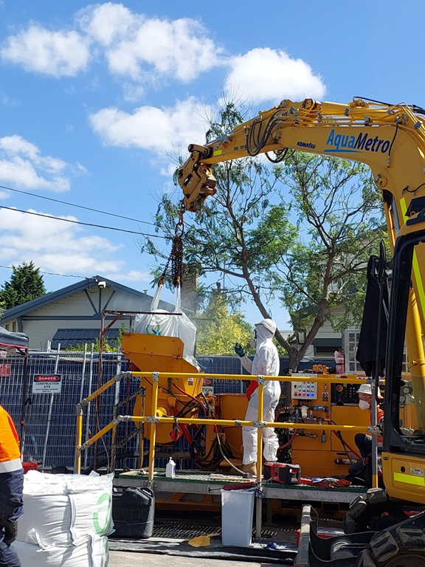 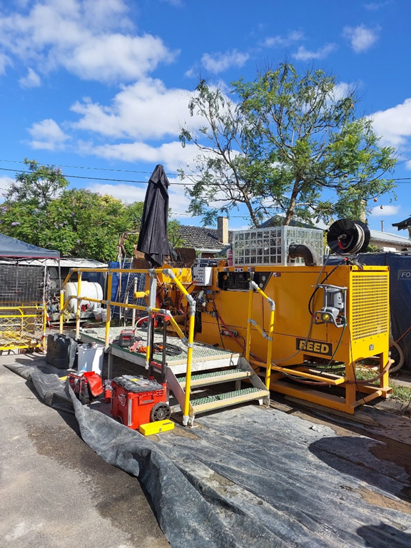

Above: Re-lining machinery set up at a Melbourne Water site.

# Contact Us

We thank you for your patience as we undertake these works, if you have any questions about the project please call **1800 960 977** or email [smallscaleprojects@melbournewater.com.au](mailto:smallscaleprojects@melbournewater.com.au).

|  |  |
| --- | --- |
| **Keep up to date with what’s happening**  For more information about this project  or our other activities please call   1800 960 977 or visit https://www.melbournewater.com.au/church-st-drain.  For an interpreter, please call the Translating and Interpreting Service (TIS National) on 13 14 50 | **Like us**  facebook.com/melbournewater  **Follow us**  @MelbourneWater  **Visit us**  www.melbournewater.com.au |